SPECCHIO Web Interface – Deployment Process

|  |  |
| --- | --- |
|  |  |
| Date | Friday, 4 November 2016 |
| Version: | 1.0 |
| Authors: | Christian Schibli, christian.schibli@students.fhnw.ch  Remo Rossi, remo.rossi1@students.fhnw.ch |
|  |  |

1. Launch the Administration Console by typing the following URL in your browser: **http://localhost:4848**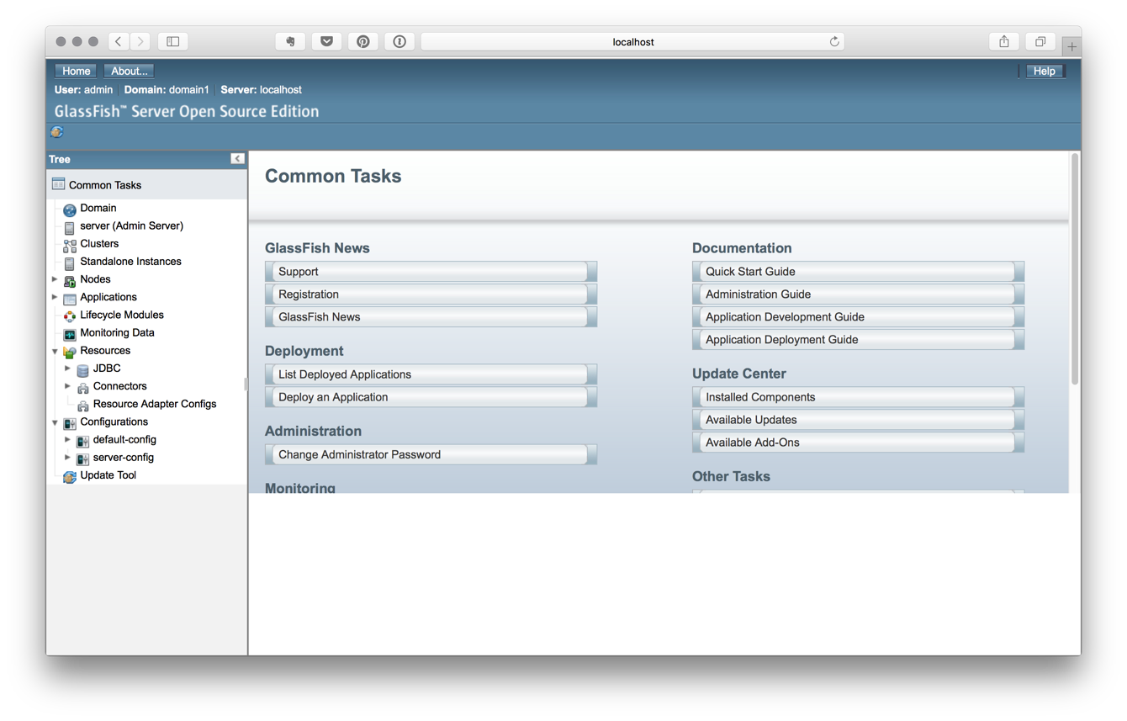
2. Click to “Applications”:  
     
   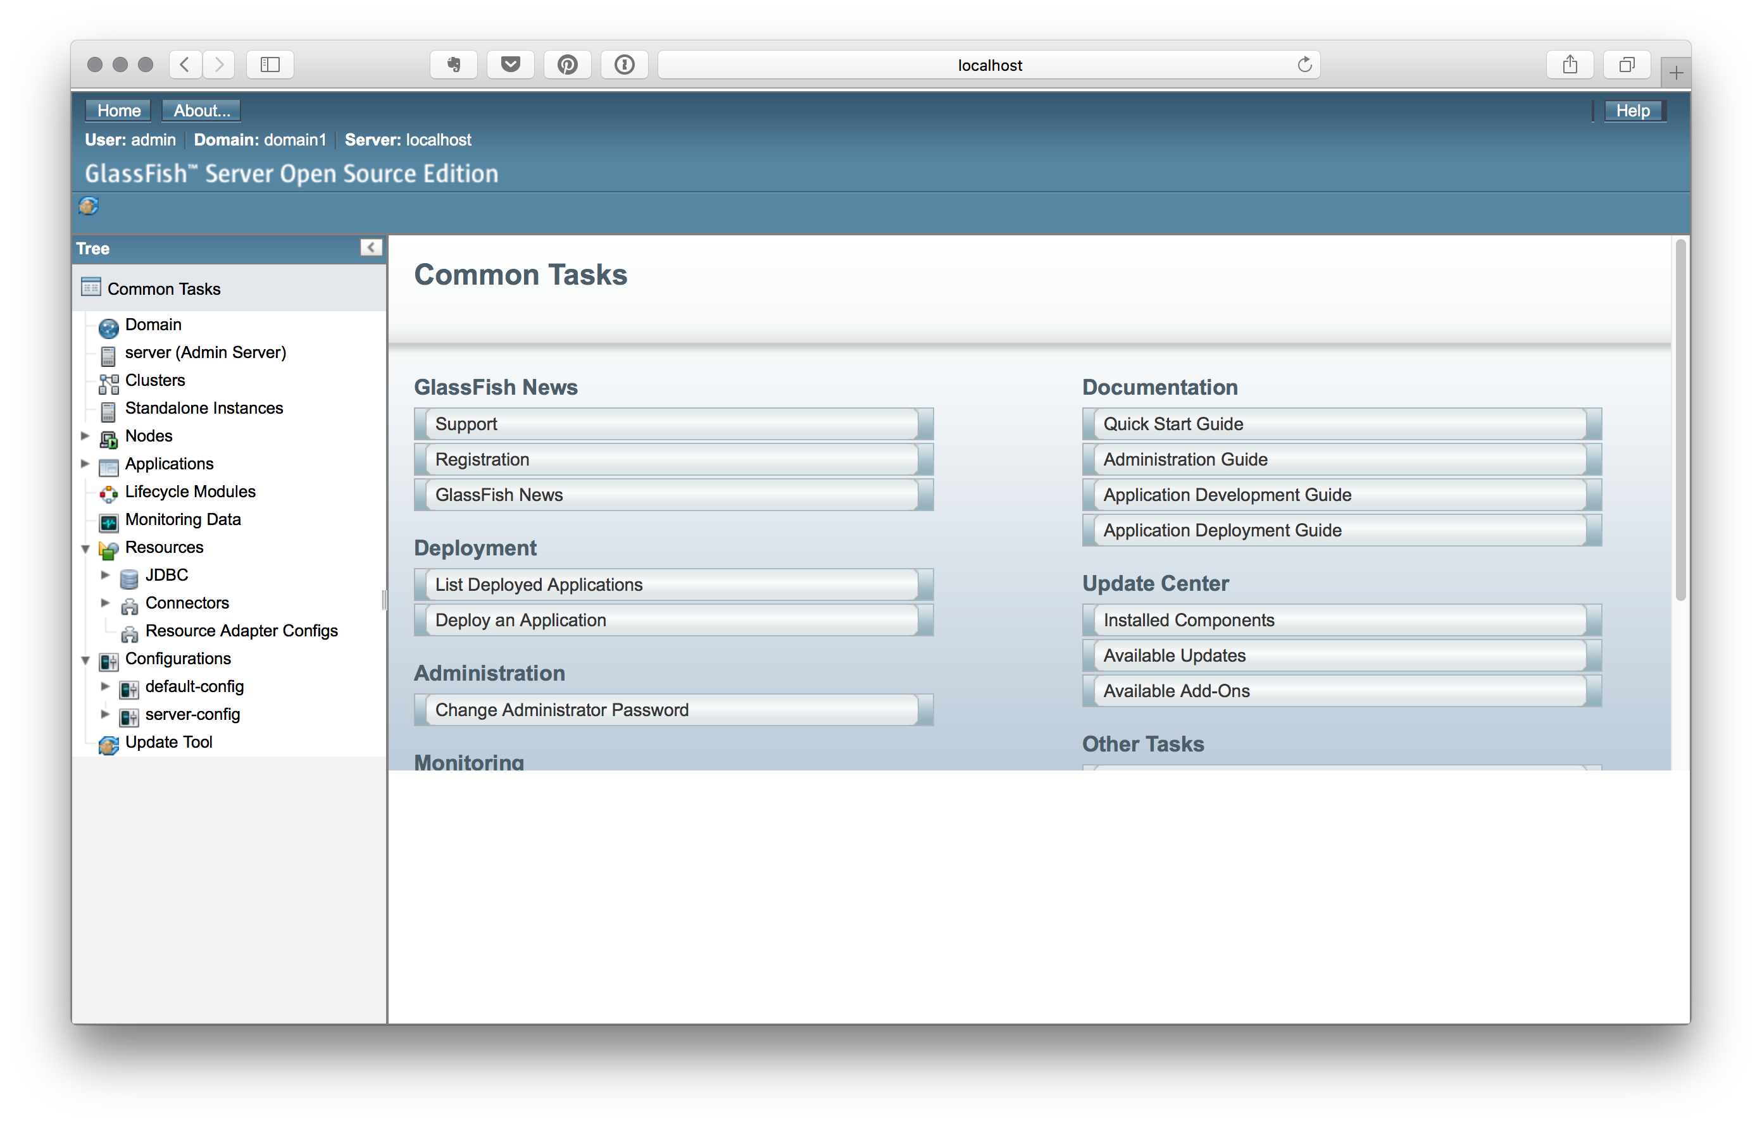
3. Click the “Deployment” Button:  
   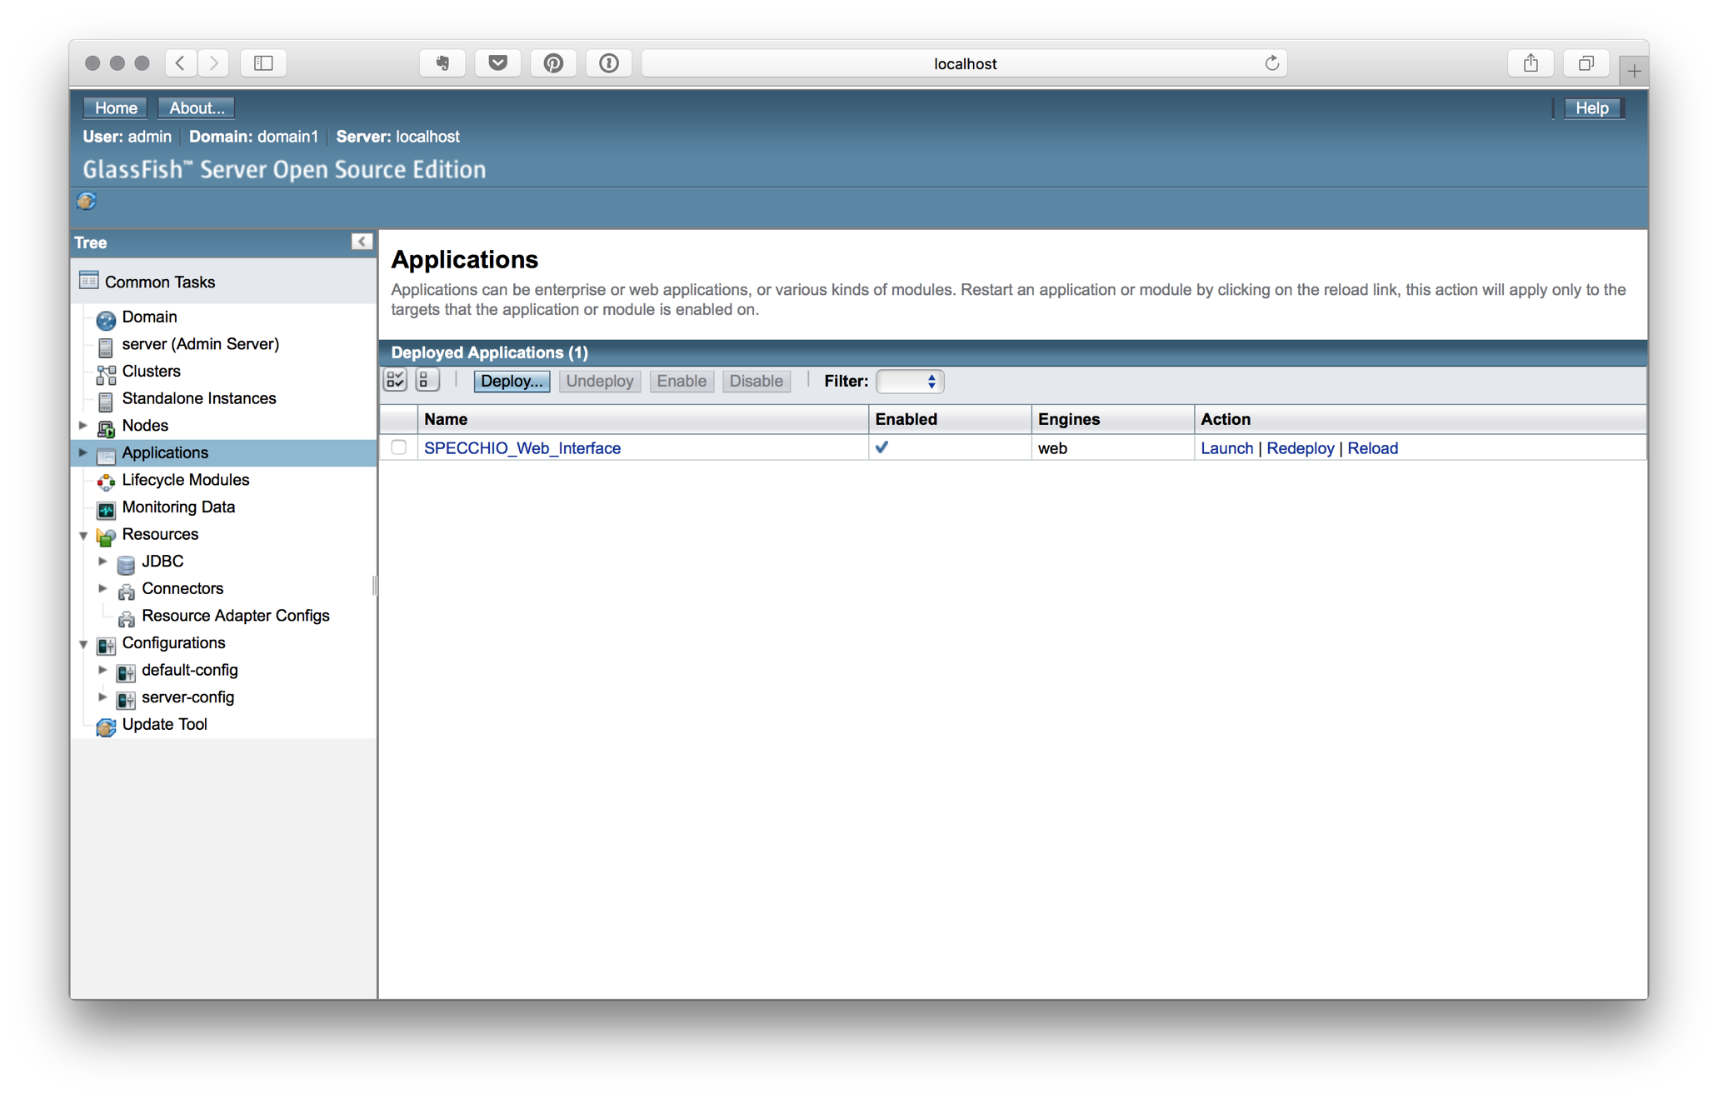
4. Click “Choose File”:  
   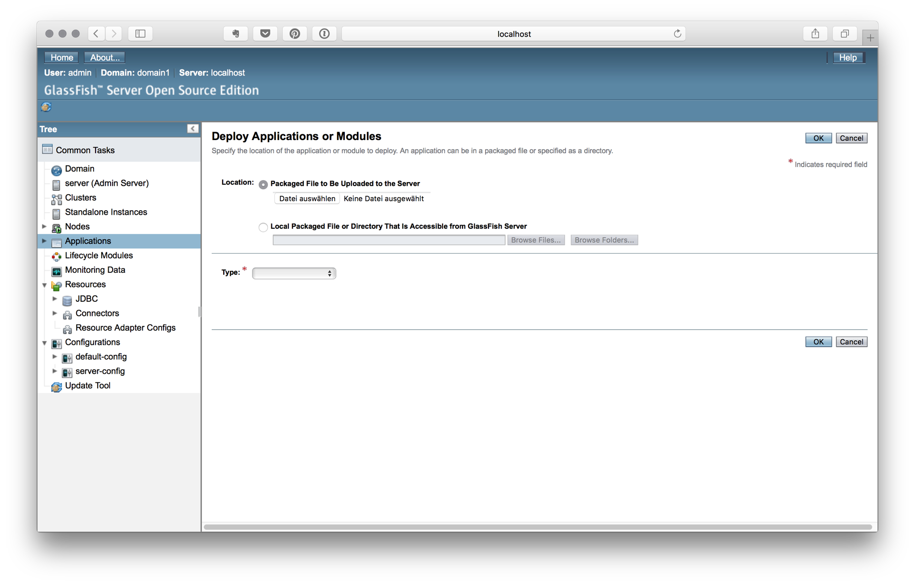  
    **Important:** filename of war must not be same as already deployed war files!   
   Moreover, filename must start with a letter, number or underscore and may contain only letters, numbers, and these characters: hyphen, period, underscore, slash, colon, hash, and semicolon.
5. Click “OK”:  
     
   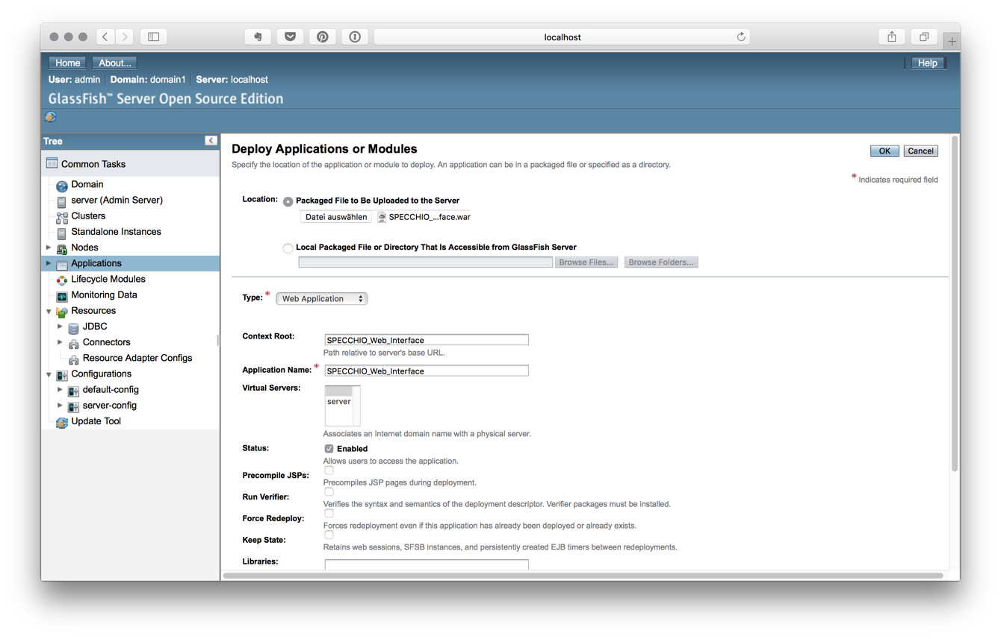
6. Click “Launch”:  
     
   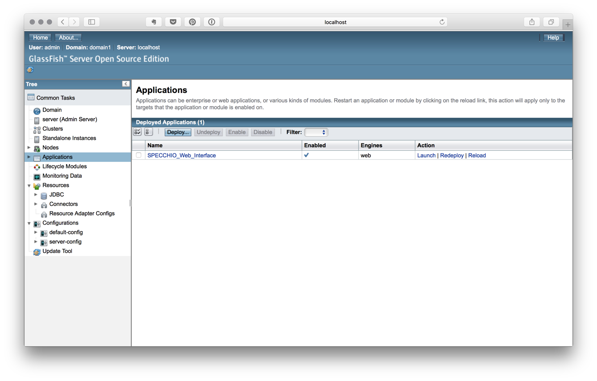
7. You get the application links which can be put in the browser:  
     
   